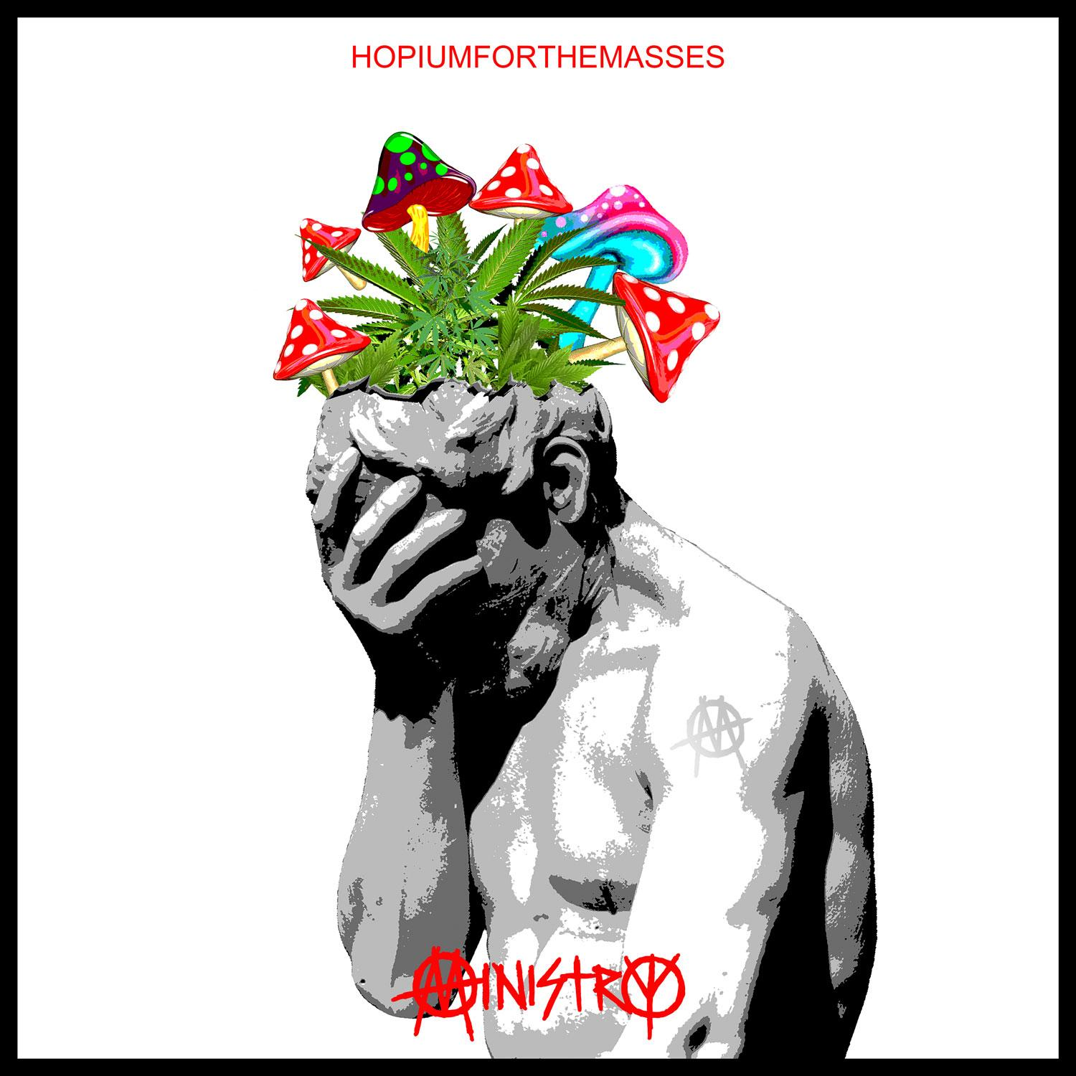

MINISTRY
HOPIUMFORTHEMASSES

Release Date: March 1, 2024

Line up: | MINISTRY online:
Al Jourgensen | Vocals  John Bechdel | Keyboards  Monte Pittman| Guitar  Cesar Soto | Guitar  Paul D’Amour | Bass  Roy Mayorga| Drums | https://ministryband.com  https://www.facebook.com/WeAreMinistry  https://www.instagram.com/weareministry/  https://twitter.com/WeAreMinistry
Regimes rise and fall. Stars shine and fade. Trends come and go. MINISTRY lives on. The six-time GRAMMY® Award-nominated multiplatinum juggernaut founded and fronted by Al Jourgensen has seeped through the darkest corners of popular culture and infected the mainstream for over four decades, gleefully spewing sonic bile between the cracks of the system's facade. Born in the eighties, they survived the nineties, weathered the turn-of-the-century, and even held on through a Goddamn pandemic. However, MINISTRY shows no signs of stopping or slowing down—even for a breath. Instead, the band—"Uncle Al,” John Bechdel [keyboards], Monte Pittman [guitar], Cesar Soto [guitar], Roy Mayorga [drums], and Paul D’Amour [bass]—cranks out another blast of anthemic industrial metal on its 2023 opus and sixteenth full-length LP, HOPIUMFORTHEMASSES [Nuclear Blast]. The guitars rip, the drums rumble, and Al's as righteously cantankerous as ever about a fucked up world ripe for a boot up its ass.

Like always, he's merely looking around at the same dumpster fire we are, but he's got a microphone.

“Just like you or anybody else, I’m simply a passenger in this lifetime,” he observes. “I’m watching social changes, political changes, and economic changes, and I comment on them because I do have a First Amendment right. A lot of people say artists and athletes should shut up and play ball. No, I’m on this trip too. If I see something, I say something. That reflects on where each album goes. Instead of staying sedentary and singing about broken relationships, inner turmoil, or whatever is hurting this week, I comment on what’s going on from the perspective of a fellow passenger.”

To say it’s been a hell of a ride for MINISTRY might be the understatement of the century…

MINISTRY’s history has encompassed game-changing classics, including gold-certified standouts The Land Of Rape And Honey [1988] and The Mind Is A Terrible Thing To Taste [1989] as well as the platinum-certified Psalm 69 [1992]—which graced Rolling Stone’s coveted “100 Greatest Metal Albums of All-Time.” Their music has scarred the underbelly of blockbuster films and television series, screeching through RoboCop, The Matrix, Steven Spielberg’s A.I. (in which the musicians appeared on-screen at the request of the late Stanley Kubrick), and all the way up to Atomic Blonde (as covered by composer Tyler Bates and Marilyn Manson). They even cooked up an official theme song for The Chicago Blackhawks.
They garnered six GRAMMY® Award nominations in the category of “Best Metal Performance.” Not to mention, they have collaborated with everyone from author William S. Burroughs to Jello Biafra of DEAD KENNEDYS and Gibby Haynes of BUTTHOLE SURFERS on wax. Their traveling circus (the real greatest show on earth) has welcomed players such as Joey Jordison of SLIPKNOT, Nivek Ogre of SKINNY PUPPY, Burton C. Bell of FEAR FACTORY, and dozens more among its demented troupe. They’ve persisted as the rare force of nature who can share a bill with NINE INCH NAILs, DEATH GRIPS, SLAYER, or GARY NUMAN. 2021’s Moral Hygiene kickstarted another era. The critically acclaimed LP wound up on year-end lists from the likes of Consequence of Sound and Loudwire, and they sold out venues coast-to-coast on tour.

They kept going though, running right into what would become HOPIUMFORTHEMASSES with the force of a runaway freight train. Conducted by Al, that train was powered by the strength of the collective—a first for MINISTRY in over two decades and a callback to seminal albums.

“I think this is the most MINISTRY-sounding MINISTRY record I’ve ever had, because it was recorded by an actual band I’ve consistently been on the road with,” Al affirms. “This is the first time in 20-something years that it wasn’t only me and an engineer. Filth Pig and Psalm 69 were very much ‘band projects’. So, this is going back to our salad days when we had a functioning group that was the same on tour and in the studio. We really knew each other’s tendencies.”

MINISTRY introduce HOPIUMFORTHEMASSES with the single ‘Goddamn White Trash.’ On the track, synths pulsate beneath a robotic sample punctuated by a plea, “We need your help.” A grimy riff snakes around propulsive percussion, kicking the door down for a hypnotic hook and the groan of a wah-drenched solo.

“It’s not anti-redneck or white trash,” Al clarifies. “It turned out to be a rallying cry. The message is, ‘Pay attention, man, because this is what you’re being made into’. They get you all riled up about transgender bathrooms or some other nonsense, and they’re taking away your Medicare and Social Security. Don’t be so easily distracted by culture war issues and read between the lines. Look at what’s in your best interest to make a better life for yourself and your family.”

Then, there’s ‘Just Stop Oil.’ A staccato rhythm underlines the venomous verses as Al ponders, “Who is the driver of the coming disaster?” In true Ministry fashion, the distortion bleeds into unexpected surf guitar.

“There are these movements around the world and disruptions at art galleries…which they’re going to have to do in order to get people to pay attention,” he goes on. “They want to pass this climate catastrophe and punt it down the line. Something needs to be done to wake everyone up.”

‘Big Dick Energy’ hinges on a stomping chant and trudging guitar groove as Al bemoans, “Toxic little man with a toxic little plan.”

“That’s about all of our misogynistic friends and the incel community, which has partnered up with the right-wing through hate-filled social media posts,” he states. “I wanted to give a shoutout to our female fans, so they know we haven’t forgotten about them. This bullshit has to stop. The right-wing focuses on the culture war, while they’re ripping us off to feed their rich benefactors and keep them in office.”

Elsewhere, chaotic riffing sets the tone for the cataclysmically catchy ‘New Religion.’ As guitars crash, Al repeats a lament like a prayer, “That’s just not right.”

“Our new religion is social media,” he sighs. “How many likes you get is not a lot different from going to a Catholic Church and counting how many blessings you get. I’ve witnessed it personally with friends, well ex-friends now. It’s their religion to be scanned upon by algorithms. Personally, I don’t think I have anything above an iPhone 5. I’m an OG. We’ve normalized social media, but this is not normal. I’ve watched lives get ruined from the disinformation age. That’s a recurring theme.”

In the end, MINISTRY have a lot of gas left in the tank, and Al’s going to ride out the shitstorm with us a little bit longer.

“Obviously, I hope you walk away like, ‘Damn, these old coots can still rock’,” he laughs. “I try to keep everyone guessing. It’s quite a fun record. We’ve evolved in an organic and natural way. I’m really not one to say this, but I’m pretty happy with this album,” he smiles.

